Date: March 26, 2021
To: Hospital Chief Financial Officers and Case Mix Liaisons
From: Claudine Williams, Deputy Director, MEDA
Subject: FY2021 Q3 Data Forum Follow-up
First, HSCRC staff would like to thank all the hospital staff who are working diligently to meet the healthcare needs of Marylanders during these challenging times. HSCRC staff continue to support you and have created a website for all HSCRC-specific COVID-19 related policies and updates: https://hscrc.maryland.gov/Pages/COVID-19.aspx.
Below is a summary of what was discussed during the FY 2021 Q3 Data Forum on March 12, 2021 and next steps.

Announcements
Grouper Transition: Staff reviewed the grouper versions that will be applied to the case mix data for RY 2022 for IP, OP and PPC data (slides 4-6).
- MHAC/RRIP/QBR (CY 2021): APR DRG and PPC version 38; current CGS version. Note: RY 2023 policies begin Jan 1, 2021 in most cases. Look for base period and performance period updates in the coming months. RY 2023 and COVID: Current policies will include COVID patients, subject to 3M grouper logic (e.g., 3M’s v38 PPC grouper will not assign many PPCs to COVID positive patients); this decision will be evaluated retrospectively.
- Market Shift (RY 2022): Temporary (Jan – Jun) and Permanent (Jan – Dec) Cancelled due to COVID-19 Emergency
- Market Shift (RY 2023): Although a determination is still to be made, will likely use CY2019 as the base period due to COVID.
- Case Mix Weights: IP Weights: 37.1; OP Weights: 3.15; IP weights use CY 2019 (12 months); OP weights use CY 2019 – Q1 CY2020 (15 months). Staff has begun work on the case mix weights for FY 2022 and hope to distribute them in April 2021, at the earliest.
The number of diagnosis codes used by the groupers are as follows:
- For APR DRG: Primary and 29 secondary diagnosis
- For PPC: Primary and 29 secondary diagnosis
- For EAPG*:
  - For the Grouped Public use files that contains only 45 CPT codes: Principal and 49 other diagnosis codes and 45 CPT/HCPCS codes from Record Type 3
  - For internal use and EAPG/Market Shift Data: Principal diagnosis code and all CPT/HCPCS codes from Record Type 3
*Staff compared the results between the two grouping methods and the differences were not substantive.
3M Core Grouper Software (CGS) Version: Staff explained that 3M releases new CGS versions for all 3 groupers on a quarterly basis, and patches to the quarterly versions based on fixes identified. HSCRC will move to the new CGS version into production once it is tested using prior 4 quarters of data for validation. If validation fails, hMetrix submits a ticket with 3M to investigate the discrepancy. Hospitals should always be using the latest CGS version of the groupers.
Quality Update: Staff reviewed the data concerns and revenue adjustment options for RY 2022 and 2023 (Slides 8-9), as well as an update on the analysis HSCRC conducted looking at the impact of incorporating additional secondary diagnosis codes in the grouper. Due to historical base periods in the quality program that is still using only 29 secondary diagnosis codes, HSCRC will continue to use only the primary and 29 secondary diagnosis codes for grouping both PPC and APR DRGs.
Staff also gave an update on the discrepancies that were found with date of death and the accuracy of the race variable in the case mix data (slides 11-12) Additional information on the results on a reliability assessment on the race variable across hospitals is available in Appendix 1 (slides 50-54).
EHR System Survey: Staff introduced a new tool available in DAVE to capture updates to hospitals EHR systems. Hospitals must review (and update if applicable) at least once every six (6) months. Hospital staff can contact hscrcteam@hmetrix.com if they need access or have questions.
Error Threshold Implementation Timeline: Staff reminded participants that the five (5) percent error threshold goes into effect for FY21 Q3, due June 1, 2021. Please email hscrcteam@hmetrix.com for questions or assistance with the new edits.
Data Forum Survey: Staff reminded all meeting participants to complete the survey (in Survey Monkey). The link was sent by March 29, 2021. Please use this opportunity to provide the HSCRC staff feedback on the data forums. If you did not receive a link to the survey, please contact hscrcteam@hmetrix.com.

Changes to Data Submission Requirements for FY 2022
New and Revised Variables and/or Codes for FY 2022: Staff reviewed the following variable and code changes for FY 2022:
- Retiring Patient County of Residence (County Code) (slide 19). If there are concerns about retiring this variable, please complete the Data Forum Survey to share your thoughts.
- Changing the Country-of-Origin codes to ISO 3166-1 Alpha-2 (https://www.iso.org/obp/ui/#home) (slide 20)
- New codes for Expected Payer and Health Plan Payer (slides 21-22)
- Revision to Accident Hour and where to report the Accident Code (slides 23-24)
New and Revised Edits for FY 2022: Staff reviewed the following new and revised edits that will be effective for FY 2022:
- New IP edits for Chronic Daily Service and Major Service to only allow for Hospitals with Chronic Beds (slide 26)
- New IP edits for Rehab Daily Service and Major Service to only allow for Hospitals with Rehab Beds (slide 27-28)
- Tightening OP Error for Dates of Service outside the From and Thru date (slides 29-30)
- New Warning Edit that looks at charge outliers by APR ad Rate Center (slides 31-32)
  - Thresholds based on statewide data and will be used to generate warning in the error reports like other warnings. The example presented on slide 32 is using statewide data the resulting outliers.
  - All data that is grouped using APR DRG (including the OP observation cases) will be subject to this edit.
  - A method is still being developed to apply this warning to OP data.
Naming Convention and New Timeline for FY 2022: Staff is also reviewed changes the naming conventions for data submissions and the timeline the format changes go into effect for FY 2022:
Staff introduced new names for preliminary and final submissions (slide 35):
- Preliminary submissions will now be called Monthly submissions (i.e., January Monthly, February Monthly, etc.).
- Final submissions will now be called Quarterly submissions, and should always contain three (3) months of data
- The submission received on or prior to the due date (Monthly or Quarterly) will considered as the final submission for that submission period
There is also a new naming convention for the IP, OP and Psych files submitted to hMetrix (slide 36).
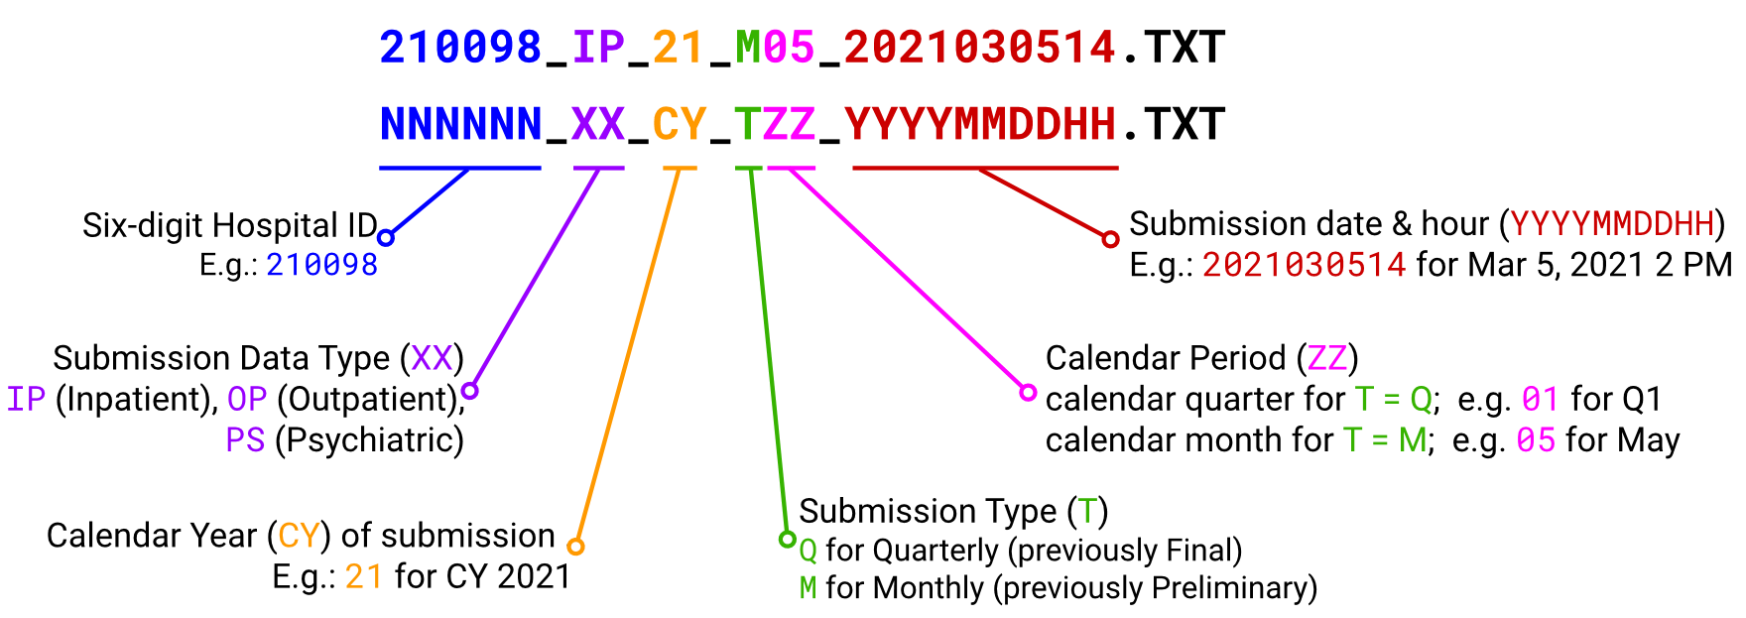
Finally, HSCRC will be providing hospitals with an extra month to update their systems for the FY 2022 formats (slide 37).
- Test Site
  - Go live August 1, 2021 for FY 2022 formats.
  - Please submit records for discharges beginning July 1, 2021
- Production Site
  - FY 2021 formats until September 15, 2021 (for FY 2021 Q4 Quarterly and FY 2022 July and August Monthly data).
  - FY 2022 Formats beginning October 1, 2021 (For FY 2022 September Monthly and FY 2022 Q1 Quarterly

Data Processing Vendor Update
Mary Pohl, representing hMetrix and Burton Policy, reported on data processing updates. Mary reminded hospitals that they could submit to any of the HSCRCIP, HSCRCOP, and HSCRC-Psych folders in RepliWeb to process the monthly data. hMetrix has instituted automated logic that can determine the type of file submitted. She also indicated the Test Site is always available for testing (for instance for a new hospital coming on board or a system conversion). Mary also reminded hospitals to use DAVE to notify HSCRC and hMetrix if the preliminary submission should be used as the quarterly final submission or to request and extension or skip.
Mary described the new Financial Reconciliation Process (slide 41-43) where hospitals will be able to download the Financial vs Case Mix reconciliation reports through DAVE. The timeline for receiving the reports will be the same as it is now. Hospitals will continue to submit the completed reconciliation reports directly to the HSCRC.
Mary presented screenshots of the new CDS-A Drug Utilization Outlier Report available on the CRISP CRS portal (slides 44-45). These reports are designed to help hospitals identify outliers in the drug units that are reported in the case mix data. The process will begin with FY 2021 Q3. Training on this tool is scheduled for April 1, 2021. To register, go to: https://crisphealth.zoom.us/meeting/register/tJwtf-2rrzsvHtLmt62h4_A3elSWx0O93cGO.
Mary also reviewed the CY 2020-2021 Roadmap that provided hospitals with a high-level view on the major activities that hMetrix will be engaging in for the next three quarters (slide 46).

Upcoming Workgroups and Next Data Forum Meeting
Staff announced one (1) upcoming workgroup meeting, the Data Submission Requirements (DSR) Review Workgroup. If you are interested in volunteering for the workgroup, please contact Oscar Ibarra (Oscar.Ibarra@maryland.gov).
The next Quarterly Data Forum Meeting is scheduled for Friday, June 11, 2021.
If you have any agenda items, please send them to Oscar or me by June 4, 2021. If you have any questions or concerns about the topics discussed above, please contact me (Claudine.Williams@maryland.gov) or Oscar Ibarra (Oscar.Ibarra@maryland.gov).

